

Q-Learning Management System
User manual

How to create a new training
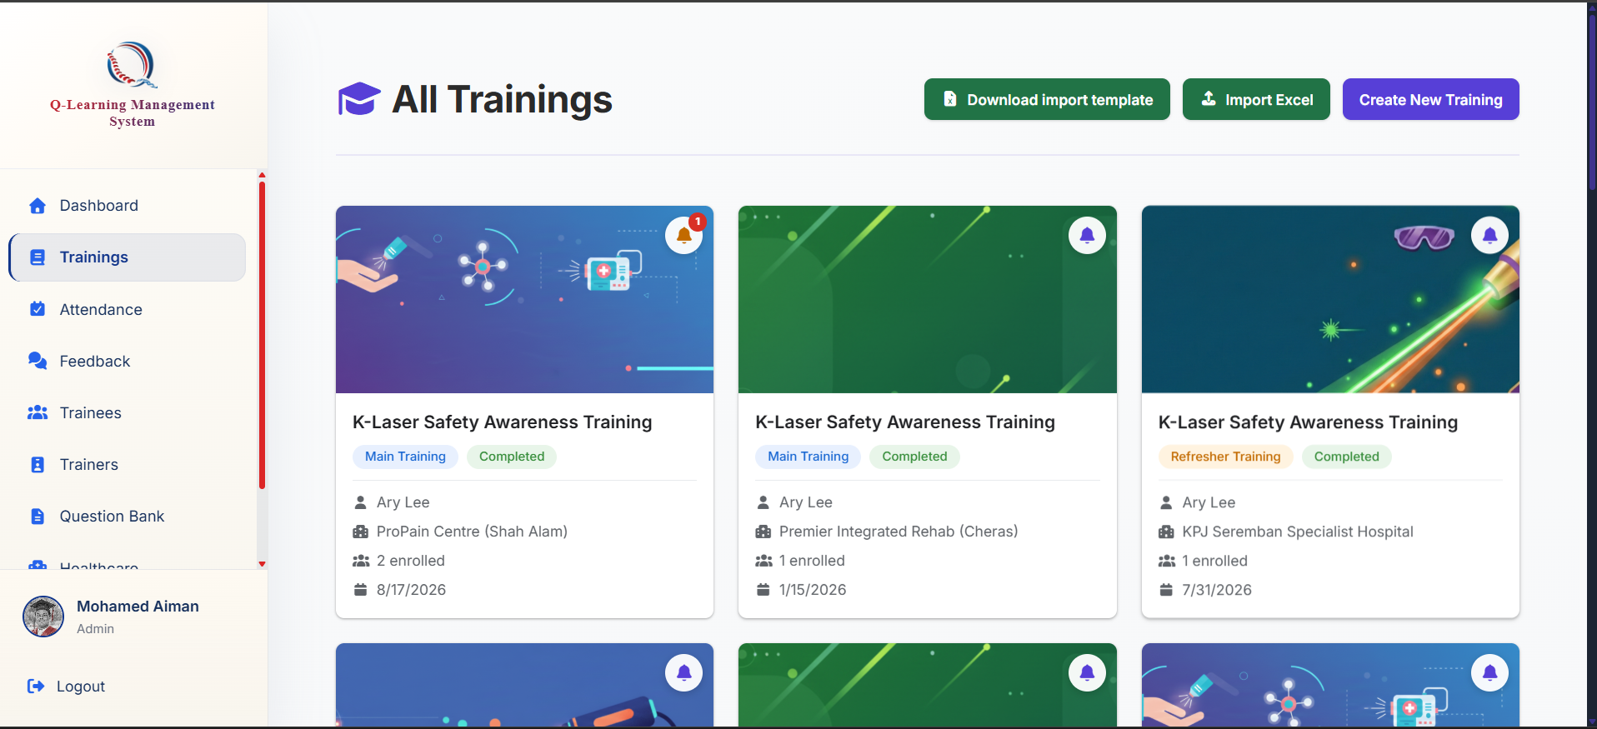
Click on the create training button

Go to the trainings tab at the top here



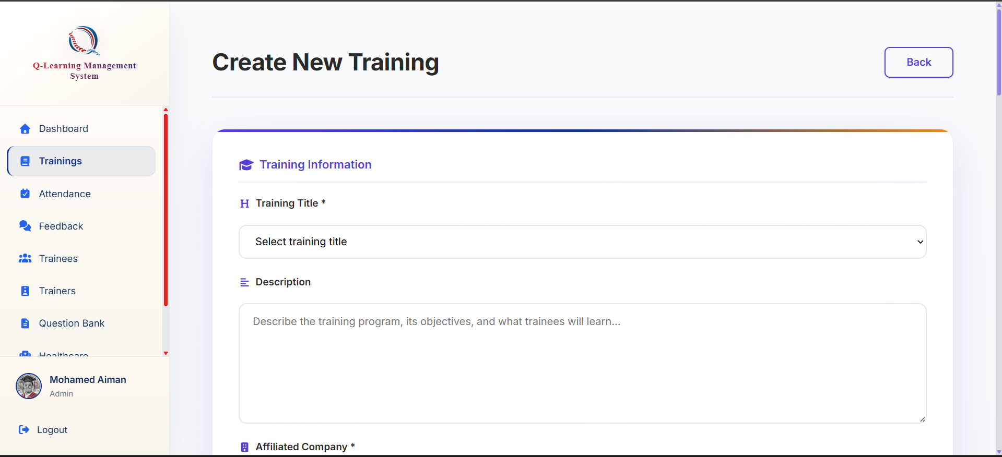
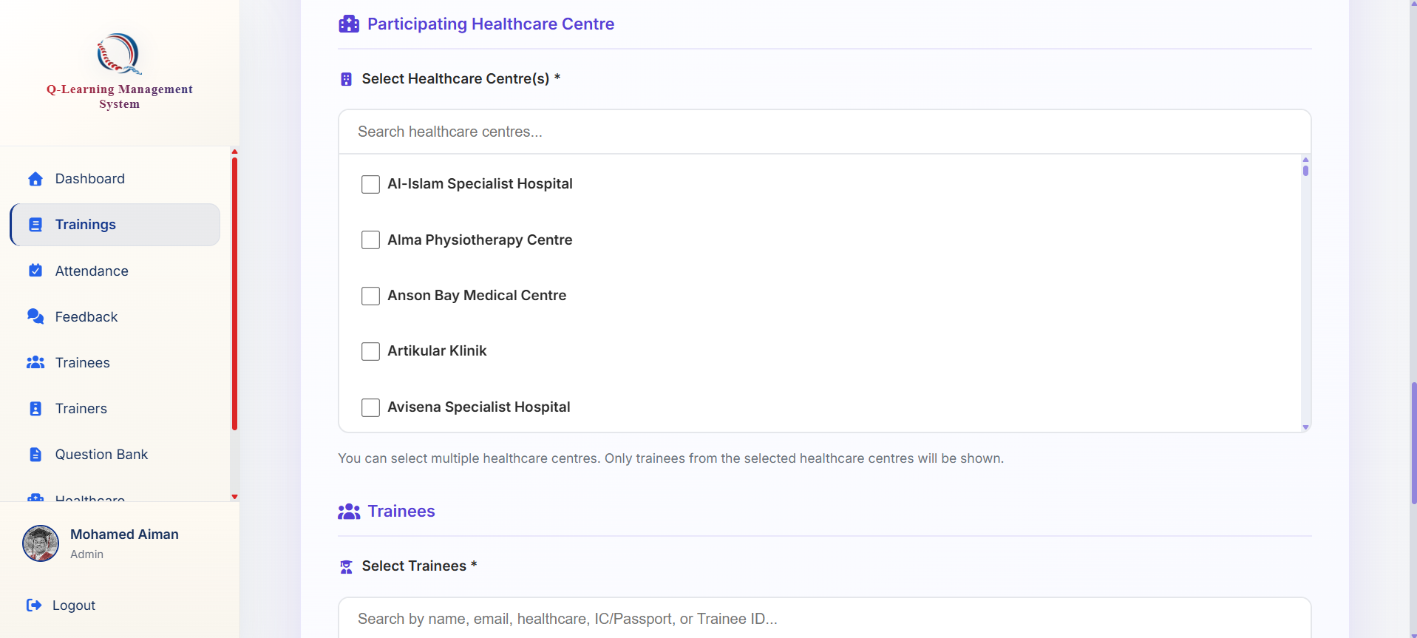
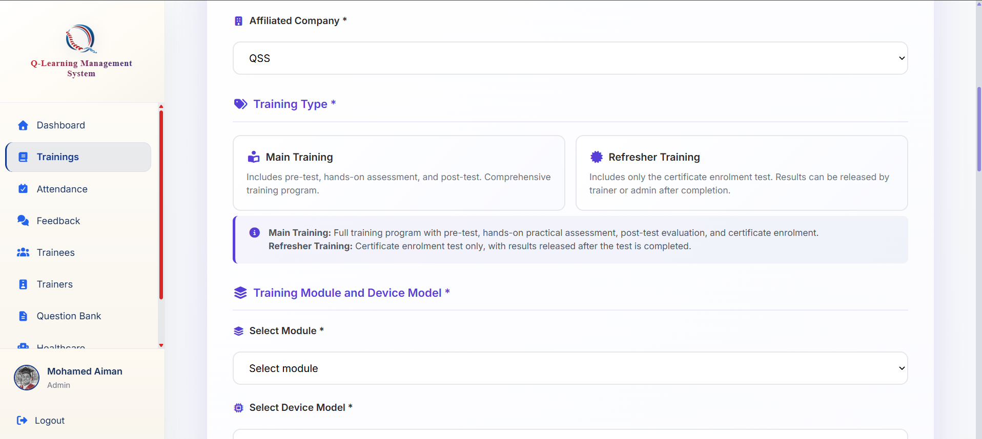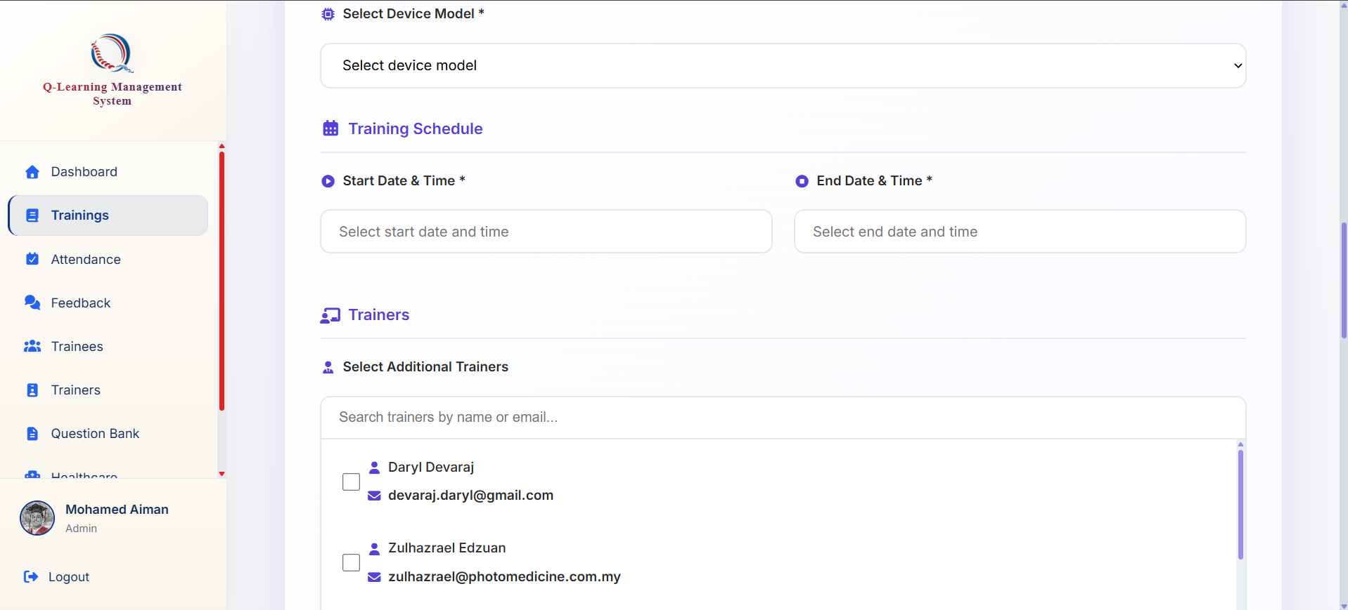
You may fill in all the details in the form; however, this is just to create a training.
You must select the participating healthcare organizations in the training to see the trainees that you can add to the training.
To get the exact training duration its not enough just to fill in the start and end dates of the training, but you will still need to create attendance records for the trainees

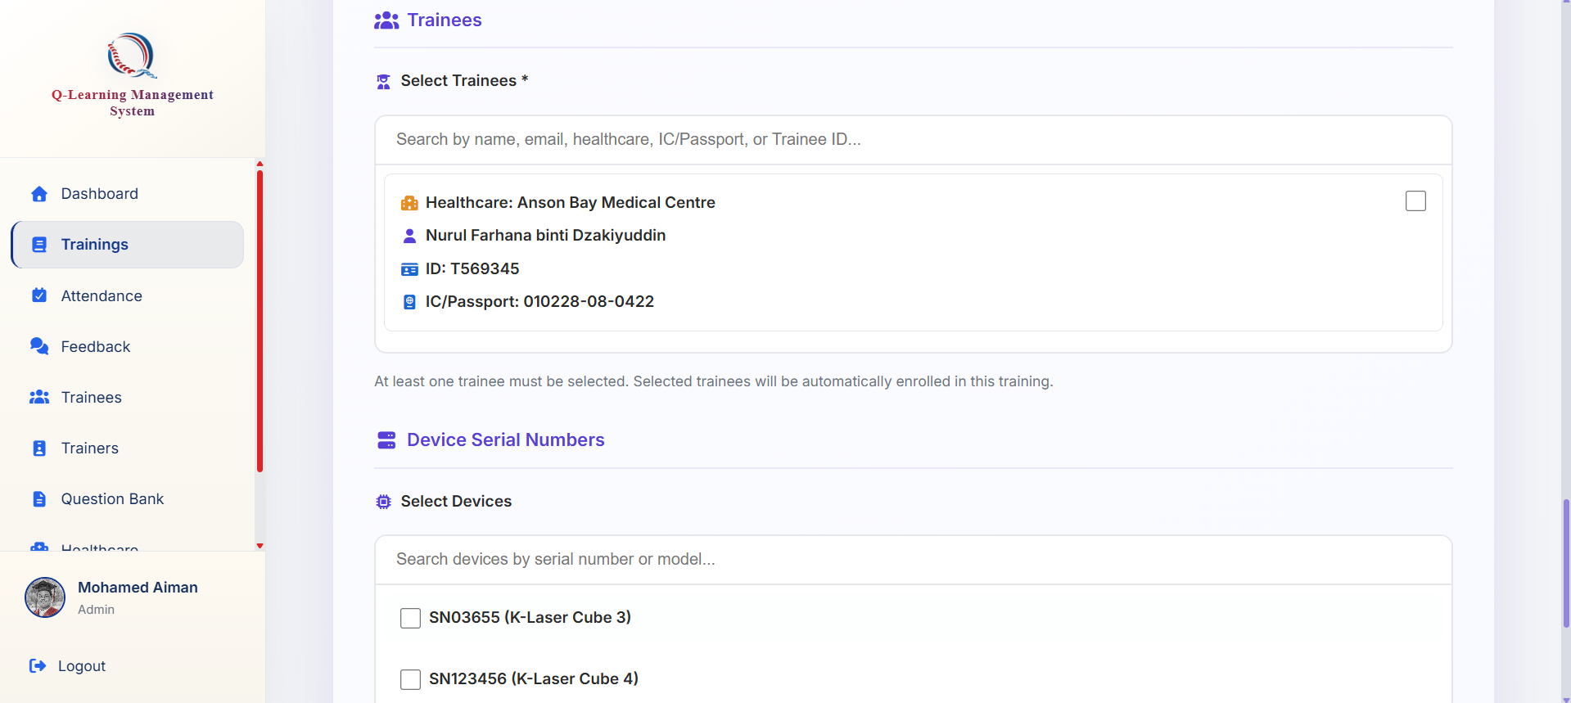

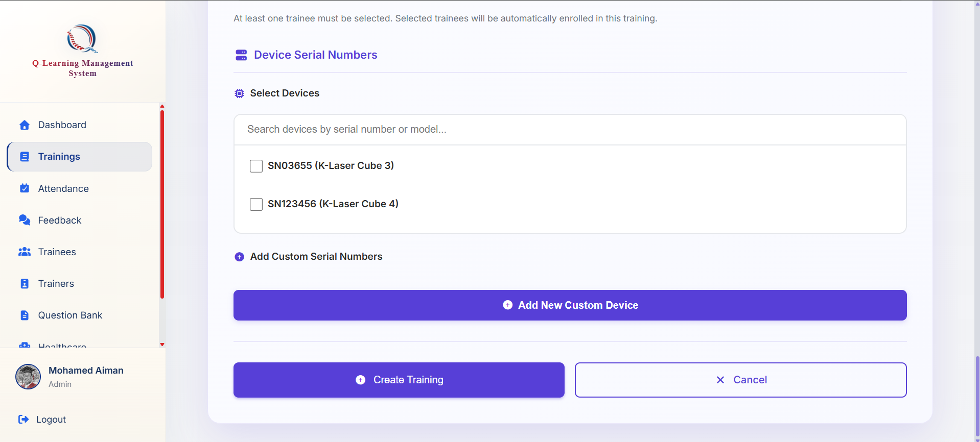

To submit and create the training just press this button

